Question 1:

It is now 9 am.
A 72 year old man, with history of hypertension, presented to AED with left sided weakness and slurring of speech at 8 am after he woke up.
BP 190/115mmHg, P 68 bpm, SaO₂ 96 RA, T=36.5°C

- What is the most important information from your history that will affect your subsequent management? (1 mark)
__________________________________________________________________________

- Named a screening tool for acute stroke (1 mark)
__________________________________________________________________________

- For this potential stroke patient, what should be done within the first hour after AED arrival?
(4 marks)
__________________________________________________________________________
__________________________________________________________________________
__________________________________________________________________________
__________________________________________________________________________
__________________________________________________________________________
__________________________________________________________________________
__________________________________________________________________________

A plain CT brain scan was obtained:
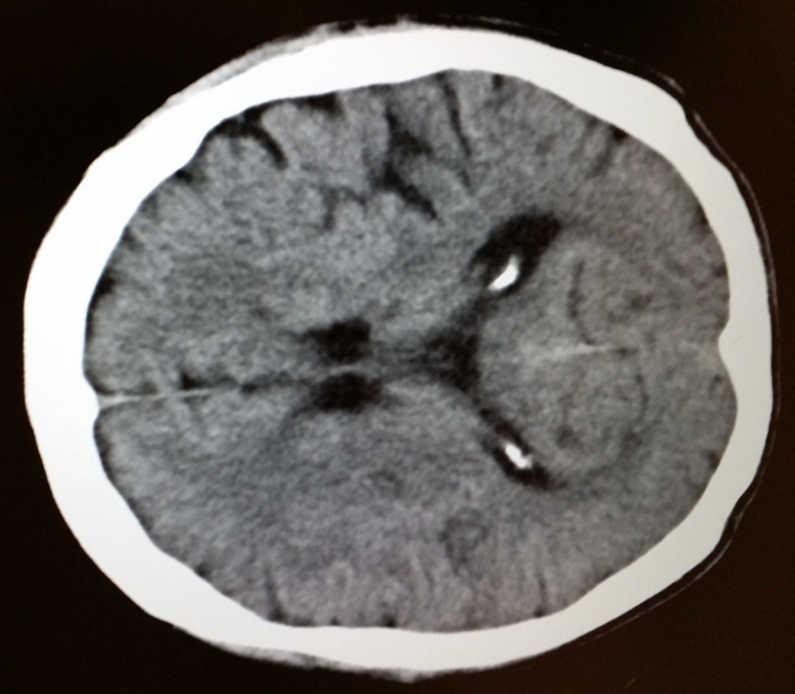
- What are the CT features suggestive of hyperacute ischaemic stroke? (4 marks)
__________________________________________________________________________
__________________________________________________________________________
__________________________________________________________________________
__________________________________________________________________________
__________________________________________________________________________
__________________________________________________________________________

Question 2:
A 26 year-old female complained of palpitation with chest discomfort for 2 hours. There was no dizziness and shortness of breath. Blood pressure was 123/70 mmHg and pulse was 150 per minute.

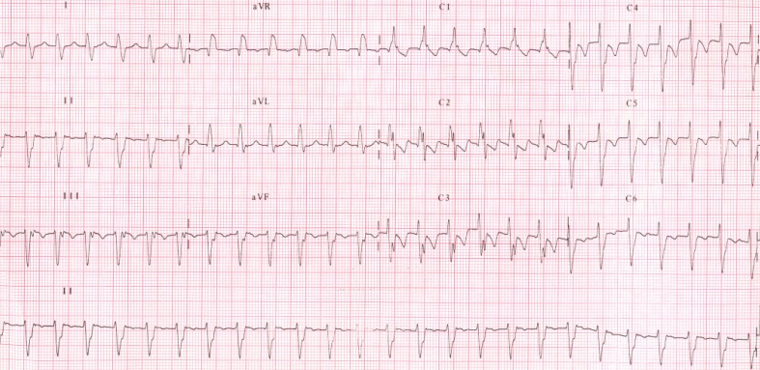
- What are the ECG findings? (3 marks)
__________________________________________________________________________
__________________________________________________________________________
__________________________________________________________________________
- What is the diagnosis? (2 marks)
__________________________________________________________________________
- What age group and which gender is this arrhythmia more commonly seen? (2 marks)
__________________________________________________________________________
- Where is the common site of cardiac origin for this arrhythmia? (1 mark)
__________________________________________________________________________
- How to manage this patient in AED? (1 mark)
__________________________________________________________________________
- What is the long term treatment for patients with severe symptoms? (1 mark)
__________________________________________________________________________

Question 3:
A 75-year-old man lived alone with no relatives in Hong Kong. He had good past health. He presented now to an A&E Department for new onset of chest pain for 2 hours.

Chest X-ray was done.
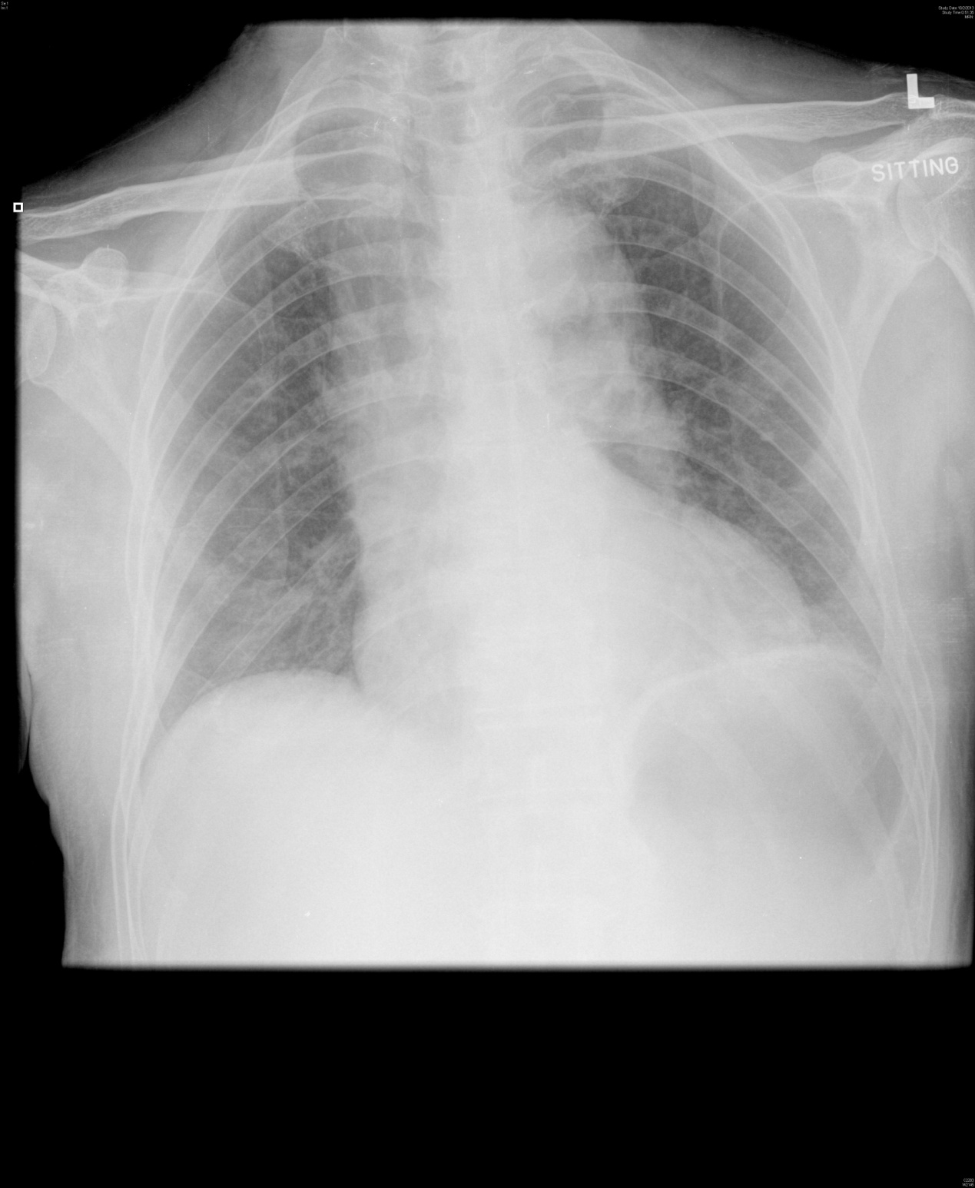
- Is this chest X-ray normal? What differential diagnosis of his chest pain may possibly be excluded ? (2 marks)
_____________________________________________________________________________

- If this patient’s BP was 200/130 mmHg, what is the drug of choice to lower his BP in A&E Department? (1 mark)
_________________________________________________________________________

An imaging investigation was done soon after. One of the films was shown here.

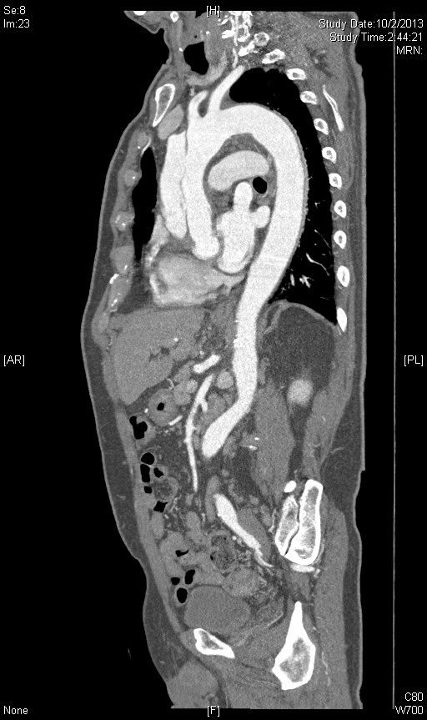

- What is the cause for this gentleman’s chest pain. (2 marks)
__________________________________________________________________________
- What is the treatment of choice for this patient ? (1 mark)
__________________________________________________________________________

This patient requested DAMA and insisted despite explanation by your senior.

- What does DAMA stand for ? (1 mark)
__________________________________________________________________________

- What is estimated risk of death for his disease in the first month if his problem is left untreated? (1 mark)
__________________________________________________________________________
- Would you allow him DAMA ? Please explain? (2 mark)
__________________________________________________________________________

Question 4:
A 77-year-old female presented to A&E Department with painful swelling below left angle of jaw for 3 days with increasing sore throat and difficulty in swallowing. Her temperature was 37.5⁰C. Her BP was 159/70 mmHg, pulse 94/min and SpO₂ 100% whilst on room air.
Physical examination found swollen and tender left submental and submandibular regions.

- Name one life-threatening condition you need to consider in this lady? (1 mark) Why is this condition life-threatening? (1 mark)
________________________________________________________________
_________________________________________________________________
- What is the sign you need to look for during physical examination? (1 mark)
_________________________________________________________________
- What other examination will you do to find out the cause of this condition? (1 mark)
__________________________________________________________________
An X-ray was done:
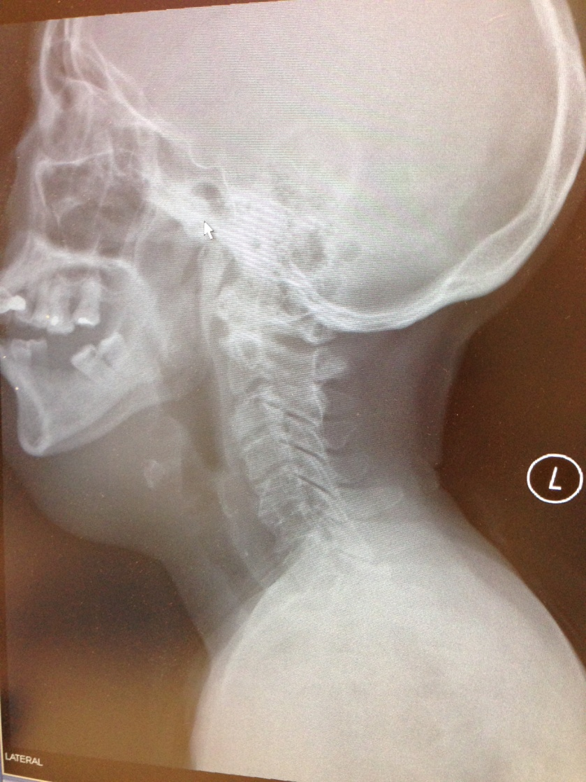
- What is the abnormality of this X-ray? (1 mark)
____________________________________________________________________________
- Name two groups of bacteria that may cause this condition? (1 mark)
____________________________________________________________________________
- If the patient’s condition deteriorated, name two airway management of choice for this patient. (1 mark)
____________________________________________________________________________
- Name two major interventions to treat this condition after airway management. (2 marks)
____________________________________________________________________________
____________________________________________________________________________
- What is the mortality rate for this condition despite treatment? (1 mark)
____________________________________________________________________________

Question 5:
A fifty-eight years old lady slipped and fell in the slope during hiking. She complained of right hip pain after the injury. She was brought to AED and the initial vital signs were as follows: BP/P 155/96 Pulse 101/min SpO2 100% on RA Respiratory rate 24/min GCS 15/15. After initial stabilization and primary survey, an AP pelvis X ray was taken.
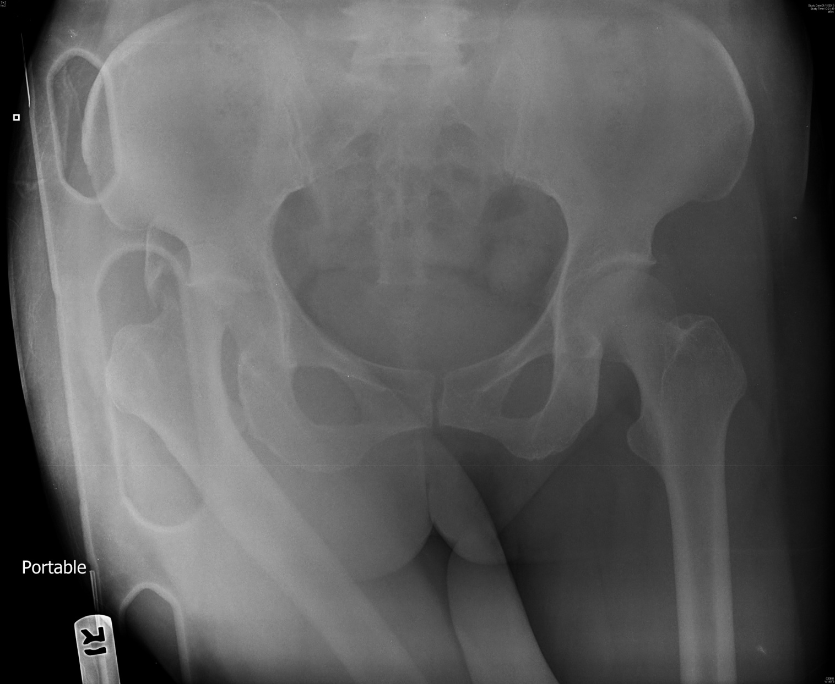
a. What are the diagnoses? (2 marks)
____________________________________________________________________________
____________________________________________________________________________
b. What will be the position of her right lower limb on physical examination. (1 mark)
____________________________________________________________________________
c. Name two complications of this condition. (2 mark)
____________________________________________________________________________
____________________________________________________________________________
d. How would you manage this patient? (2 mark)
____________________________________________________________________________
____________________________________________________________________________
e. Name two techniques involved in your management of such condition. (1 mark)
____________________________________________________________________________
____________________________________________________________________________

f. How would you manage this condition if the above-mentioned techniques are failed? (1mark)
Give two possible causes for the failure. (1 mark)
____________________________________________________________________________
____________________________________________________________________________

***************************** the end ********************************

